**Design Approach for Spread Footings Supporting the Seismic Force Resisting System**

Updated 06/30/2021

Verified by DSA people

We propose to do the following:

1. Soil stress check. Use the load combinations specified in Section 1605A3.2 (ASD) to show that the soil under the spread footings is adequate (Q ≤ Qas) to resist the loads imparted by the superstructure. This approach is consistent with Section 1802A.1. **No Omega**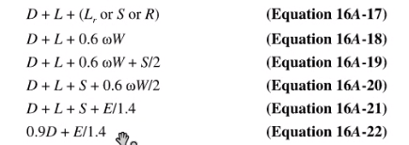
2. Verification of overall structural stability. **TENSION ON TIEDOWNS AND SLIDING**. Use the load combinations specified in Section 1605A3.2 to demonstrate that the chosen footing sizes, interconnecting grade beams, and tiedown anchors successfully preclude the limit states of sliding and overturning. This approach is consistent with Section 1617A.1.16. **NEED TO VALIDATE TWO THINGS, OVERTURNING AND SLIDING.** **SO THE DESIGN OF THIS IS DONE WITHOUT THE USE OF OMEGA**. **ASD LOAD COMBINATIONS**. **No 25% reduction should be taken here.**
3. Concrete element strength check # 1. Seismic load effects. Use the load combinations specified in Section 1605A.2 (LRFD) to show that the design strength (fMn, fVn, fPn ) in the elements exceeds the required strength (Mu, Vu, Pu). No Omega in LRFD case.
4. Concrete element strength check # 2. PUNCHING SHEAR OF FOOTING, PUNCHING SHEAR OF GRADE BEAMS. **THIS INCLUDES OMEGA**. Seismic load effects with overstrength. Use Em equations 6 and 7 of ASCE 7 Section 2.3.6 instead of Equations 16A-5 and 16A-7 to show that the design strength (fMn, fVn, fPn ) in the elements exceeds the required strength (Mu, Vu, Pu). This approach is consistent with Section 1617A.1.16. 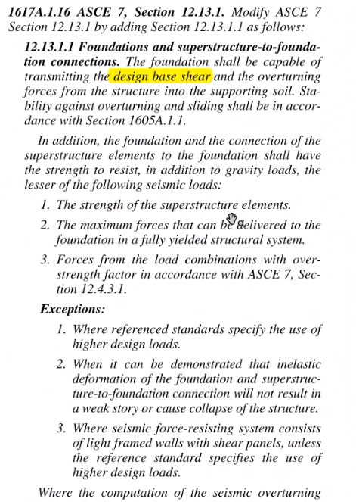 Two items to note:
   1. There is no code requirement to check the foundation-to-soil interface at the load combinations associated with seismic with overstrength.
   2. For checking the design strength of the spread footings, the soil pressure under the footings is allowed to reach a maximum value of WQas = FOSQas.
      1. This means when design for strength of the footing, check LRFD no omega for Mn, Vn, Pn, LRFD with Omega for punching shear, and Omega factored allowable soil pressure, and design for the envelope.